Nursery Activities
This week the theme is space. Here are some lovely spcae stories to share. Aliens Love Underpants, Whatever Next, The Way Back Home, Roaring Rockets.
Remarkable Rockets
Use junk modelling or craft items you have around your house to create your own rocket. Toilet roll tubes are a good starting point. You could have rocket races in the garden:
Tie a string up at an angle or use the washing line.
Blow up a balloon and sellotape it to your rocket. Hold the end of the balloon but do not tie it.
Let the balloon go and watch your rocket fly!

Have a Space Themed Party/Picnic
Support your child to use tin foil to create shiny space suits for their teddies and dolls. They could have a space-themed teddy bear’s picnic afterwards where they share the biscuits in the next activity! Make yummy star biscuits to share at the picnic. They could share them at their space themed teddy bear’s picnic.
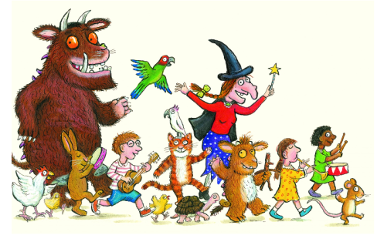Read, read, read it is so important that children hear story language. Read favourite stories that the children can join in with. The rhythm and repetition is very important for early reading. Julia Donaldson books are fantastic for this. BBC I-Player have some lovely stories available at the moment.
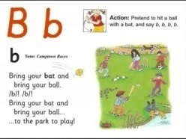Youtube Jolly Phonics Phase 2 https://www.youtube.com/watch?v=1Qpn2839Kro – The children should be able to sing the songs and join in with the actions.
Try Cosmic kids yoga. https://www.cosmickids.com/category/watch/
We have done this together and they really enjoyed it.

