Nursery Activities
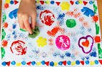Vegetable/fruit printing is great fun. You can explain to the children about healthy eating and why it is important that we eat plenty of fruits and vegetables.
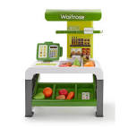Play shops together, encourage the children to talk about the foods and use money to pay for the foods. Count items of food, discuss the colours and sizes of objects.

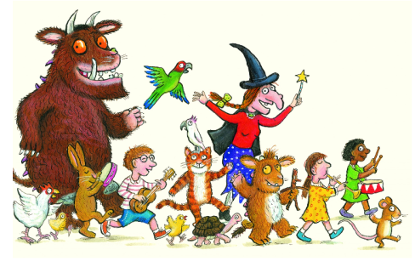Read, read, read it is so important that children hear story language. Read favourite stories that the children can join in with. The rhythm and repetition is very important for early reading. Julia Donaldson books are fantastic for this. BBC I-Player have some lovely stories available at the moment.
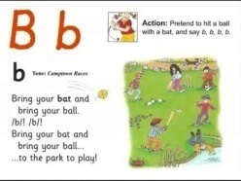Youtube Jolly Phonics Phase 2 https://www.youtube.com/watch?v=1Qpn2839Kro – The children should be able to sing the songs and join in with the actions.
Try Cosmic kids yoga. https://www.cosmickids.com/category/watch/
We have done this together and they really enjoyed it.

