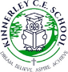

Learning Project WEEK 3 – Viewpoints
Age Range: Reception Each Task 20-30 minutes then have a break
Weekly Maths Tasks (Aim to do 1 per day)  Tasks can be repeated if enjoyed, so as long as at least 3 different tasks a week. | Weekly Reading Tasks and Writing tasks  (Aim to do 1 per day)Tasks can be repeated if enjoyed, so as long as at least 3 different tasks a week.
- Watch a Numberblocks clip each day at: BBC or CBeebies. Use this guide here to give you ideas on what to do with your children whilst watching an episode.  - Working on Numbots - your child will have an individual login to access this.  - Look out of the window and count how many houses or buildings can be seen.  - Go on a shape hunt and see how many different 2D and 3D shapes you can identify.  - Play the helicopter game on top marks to identify different numbers. | - Reading a variety of books at home. Your child could share a book everyday. This can be reading a book aloud everyday or sharing a book with an adult.  - Listen to a story read.BBC I-player. Bedtime stories. Also Amazon are doing free stories for children to download and listen to.  - Ask your child to write out the tricky words they are working on at the moment on pieces of paper and turn them into a pairs game.  - Ask your child to draw or write a shopping list to help plan for the weekly shop. Encourage them to ask all family members views on what they would like to eat that week.  - Ask your child to help plan a movie night/ afternoon. Select two films. Ask them to draw a picture to represent each film or write out the title. Ask them to speak to each member of the house to find out their view on which film they would like to watch. Ask your child to write each person’s name under their chosen film.
Weekly phonics  Tasks (Aim to do 1 per day)  Again repeat repeatrepeat! | Weekly Spellings
- Daily phonics - your child to practice their sounds and blend words. Interactive games found on link below.  Reception – Phase 4 now to consolidate phase 3.  - Phonics play  - Top Marks | This weeks spellings are:  A recap of our tricky words: they, was, all, are  Practise for 4 days and test on a Friday – send me the results on See saw (when it’s up and running)
Learning Project - to be done throughout the week: My Family
Again Maximum 1 task a day.
The project this week aims to provide opportunities for your child to learn more about different viewpoints. Learning may focus on physical viewpoints in terms of what you can see outside of the window at home, what others can see looking into your home and then progress onto personal viewpoints and of others.
How do we differ from others?-Ask your child to look in a mirror at their hair colour, eye colour, skin colour. Ask them to create a self-portrait using either felt-tips, crayons or paint. Look at some pictures in books and magazines. Does everyone look the same way as them? How do people look different?
Imagine another world outside the window-Close the curtains and ask your child to imagine that the house is in a new imagined world. What do they imagine? Is it snowy? Are there dinosaurs/ monsters in the new world? Ask them to tell you a story about it…
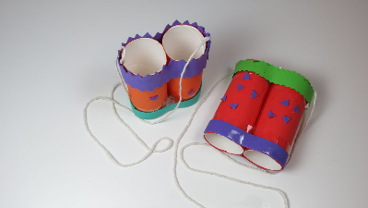
Go on a sight hunt-Support your child to make a viewfinder. Cut out a square of card from an old cereal box/ cardboard. Cut a smaller square out of the centre. Take your viewfinder around the house and garden and explore what things you can see. Alternatively, you could create a pair of binoculars as pictured. Your child could write a list of the things they see or draw/ paint a picture. If you have a tablet or phone that could be used by your child they could do the same activity but using photographs to record.
