Nursery Activities

Loose Parts
“A‘loose parts’ tool, is open-ended;children may use it in many ways and combine with other loose parts through imagination and creativity. Nature which excites all the senses, remains the richest source of loose parts.” Richard Louv, Author Take a look at this website to get lots of ideas for loose part play.
https://www.playscotland.org/parents-families/loose-parts-play/

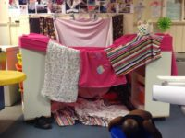
Den Building
You can use: sheets, blankets, beach towels, cushions, cardboard boxes and a good idea to clip them together is to use pegs.
You can use chairs indoors and outdoors to make the structure, or large bits of woods and make a tepee.
Scatter the cushions and pillows on the floor to make the ground cosy.

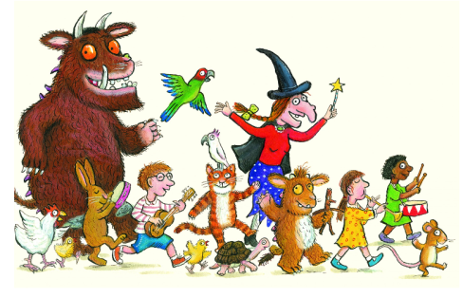Read, read, read it is so important that children hear story language. Read favourite stories that the children can join in with. The rhythm and repetition is very important for early reading. Julia Donaldson books are fantastic for this. BBC I-Player have some lovely stories available at the moment.
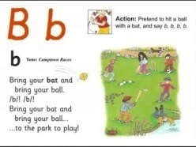Youtube Jolly Phonics Phase 2 https://www.youtube.com/watch?v=1Qpn2839Kro – The children should be able to sing the songs and join in with the actions.
Try Cosmic kids yoga. https://www.cosmickids.com/category/watch/
We have done this together and they really enjoyed it.

