Nursery Activities
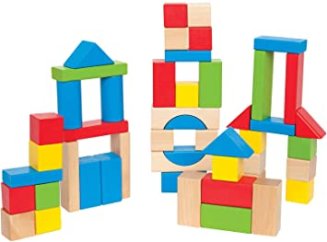Building and learning to balance is really important for children. Encourage the children to build with whatever you have, wooden blocks, lego, coloured blocks, stackers. Let the children explain what they have built and encourage them to explain how they built it and why they did it in that way.

https://www.topmarks.co.uk/maths-games/5-7-years/counting This website is great for games. The children are very familiar with the counting games in particular the teddy and gingerbread man games. This will develop their counting skills and numeral recognition.

Go on a shape hunt around your house or outside wherever you can. See what different shapes you can find. What is the most popular shape? Can you identify any 3D shapes?

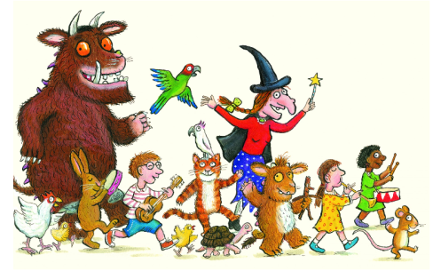Read, read, read it is so important that children hear story language. Read favourite stories that the children can join in with. The rhythm and repetition is very important for early reading. Julia Donaldson books are fantastic for this. BBC I-Player have some lovely stories available at the moment.
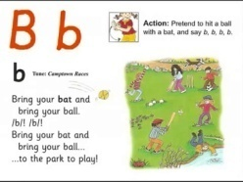Youtube Jolly Phonics Phase 2 https://www.youtube.com/watch?v=1Qpn2839Kro – The children should be able to sing the songs and join in with the actions.
Try Cosmic kids yoga. https://www.cosmickids.com/category/watch/
We have done this together and they really enjoyed it.

