Nursery Activities
https://www.bbcgoodfood.com/howto/guide/playdough-recipe Here is a good playdough recipe. If you can make it it is a great resource to use with your children. They can cut, roll, squash and squeeze, all of this is developing their fine motor skills ready for when they start to write. Encourage them to tell you what they have made in order to develop their imaginative skills and language and communication skills.

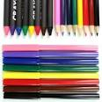Mark making is an essential skill which children need to do lots before they start to write. Giving meaning to the marks they make is the first step in learning to write so let’s encourage them to do it! They can use chalk, paint, crayons, pencils, water and a paintbrush outside. Encourage them to explain what they have created.

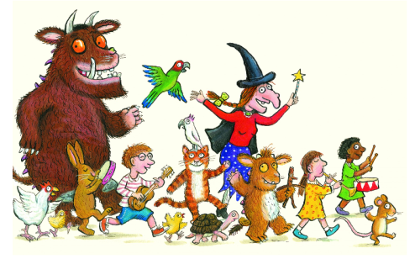Read, read, read it is so important that children hear story language. Read favourite stories that the children can join in with. The rhythm and repetition is very important for early reading. Julia Donaldson books are fantastic for this. BBC I-Player have some lovely stories available at the moment.
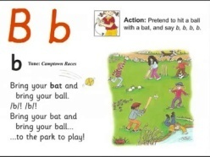Youtube Jolly Phonics Phase 2 – The children should be able to sing the songs and join in with the actions.
Try Cosmic kids yoga. We have done this together and they really enjoyed it.

