Nursery Activities
I hope that you are all enjoying some time at home with all of your families. I am luckily very well and enjoying some special time with my family. I am missing you all so I thought that I would give you some fun things to do to keep you busy!
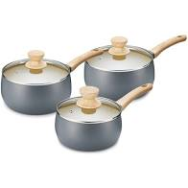Get out the pots and pans and some wooden and metal spoons. Let the children explore the different sounds. See if they can tap to the beat and sing songs while tapping to the beat, model for them to copy.
Fill the washing-up bowl with water and bubbles if you want. Encourage the children to fill and empty containers. Repeat the language of full and empty and half full or half empty.
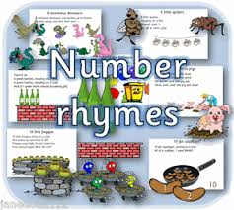Sing some number rhymes I’m sure the children will have their favourites. 5 little ducks, 5 little speckled frogs, 1,2,3,4,5. While singing use your fingers to represent the numbers. Ask the children can you show me 1 finger, 2 fingers.....up to 10.
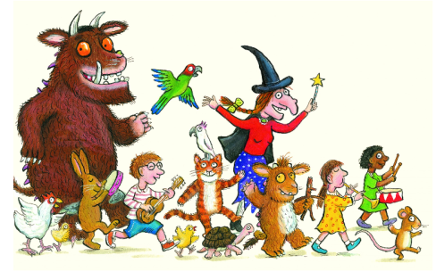Read, read, read it is so important that children hear story language. Read favourite stories that the children can join in with. The rhythm and repetition is very important for early reading. Julia Donaldson books are fantastic for this. BBC I-Player have some lovely stories available at the moment.
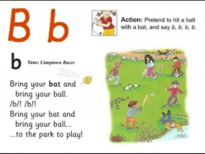Youtube Jolly Phonics Phase 2 – The children should be able to sing the songs and join in with the actions.
Try Cosmic kids yoga. We have done this together and they really enjoyed it.

