23rd November 2018 (Insert for Weekly School Newsletter)

Dear Parents/carers,
Just to keep you up to date with ECHOplus100. This message came from Jess, after she had been told about our successful fund-raising Bring and Buy sale.

LEOs,
Thank you so much for your fundraising work so far. The past two weeks we have been very busy at Echo - working hard to distribute clothes to all residents in the Hotspot (camp). We gave each person an appointment time to come and visit our 'boutique shop', where they could come and choose clothes. Each person was allocated a number of points, and they could 'spend' their points as they wished. We drove 8 people at a time to the shop, they had 45 minutes to choose their clothes, and then we drove them back. We did this for 500 people.

However in this distribution we only gave out clothes, no warm winter jackets or shoes. We will be distributing warm jackets and shoes at the end of November, as many people are still just walking around in flip flops. However right now we do not have enough shoes for everybody, and so we are in the process of fundraising to buy more. The money you have raised already for Echo is a huge help towards this and will help us make sure each resident can come to the 'shop' again, and chose a pair of shoes they like.

We have many new refugees arriving to Leros recently, and the weather is becoming colder, so it is a big priority for us to make sure everybody can receive shoes or boots.
Thank you so much for your continued support.
Jess.

In class, we discussed whether we should provide football boots or everyday footwear. We tried to imagine what it would be like to have no shoes. We wrote some poems.
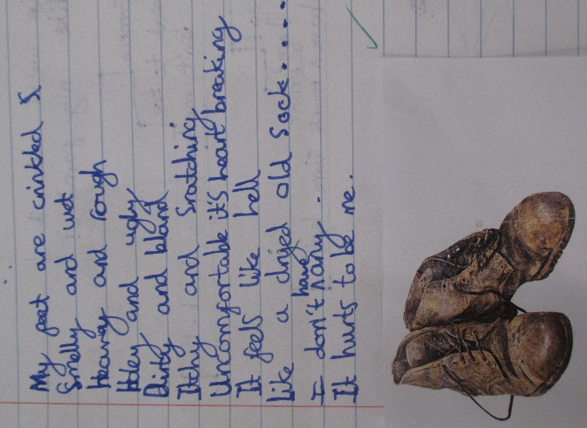
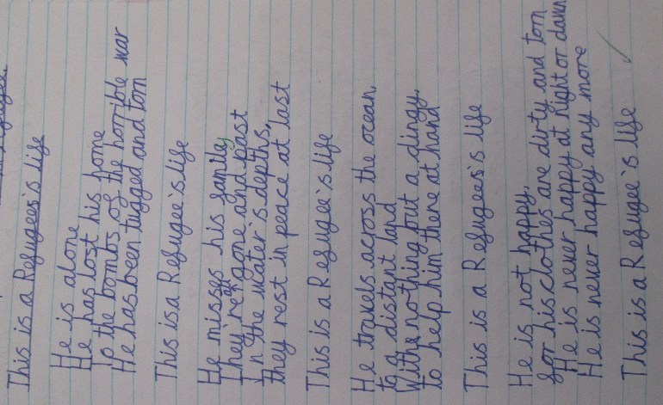
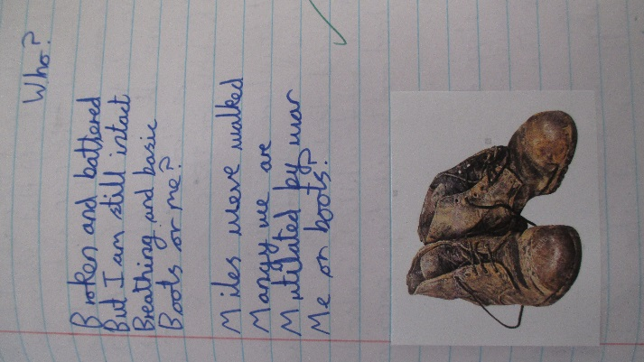

The decision was unanimous. We felt we should raise money for footwear, and to send our first chunk of money (£320) to ECHO100plus as soon as possible.
I duly informed the charity’s founders, who sent us this response.

Dear Sarah,
This is amazing! Thank you so much!!! This is amazing!!! I did not quite understand, whether you collected things to send over, or whether you collected money. For money, you can just transfer onto our account and I will give you bank details below. If it is things, it depends how much you collected. We would need a rough estimation in Kgs for this and I can then take care of a shipper. Hope to meet you one day! Maybe you can come and visit Leros?
Best, Catharina Kahane

Whilst we would love to visit Leros (!), LEOs felt it would be more productive if they put all their efforts into fund-raising.
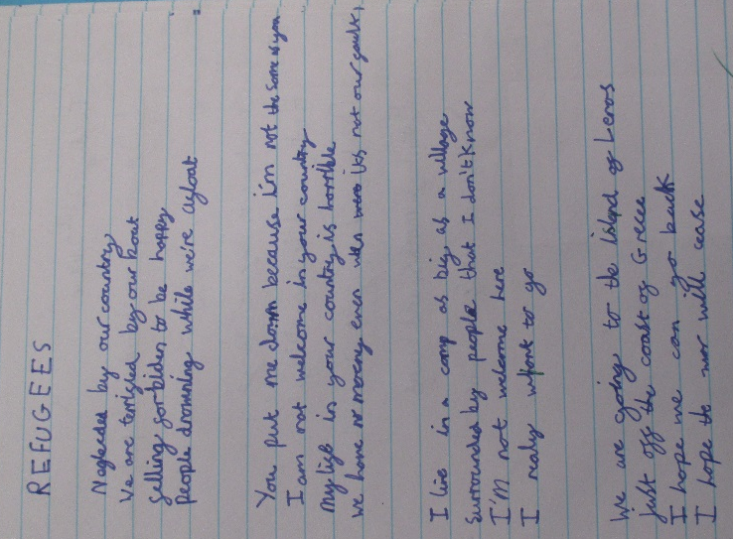
Here are some poems we wrote, thinking about refugees and how they might feel.
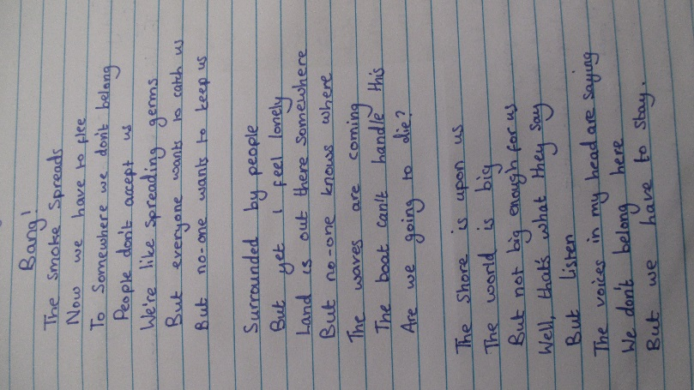
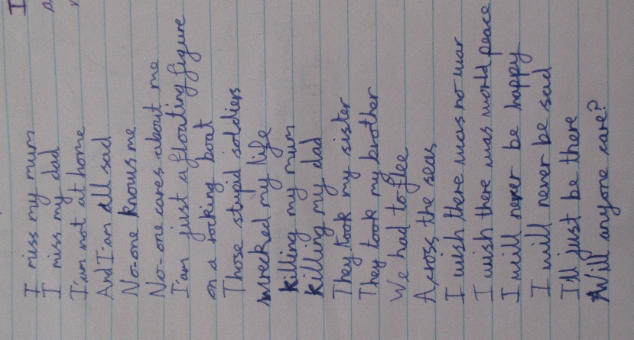
We should feel proud of all the children at Kinnerley, who believe passionately we should support and help others who are not as fortunate.
Thank you for your continued support. One final fund-raiser to be announced. (Watch this space!)
Mrs Fogarty (LEOS Class Teacher)

