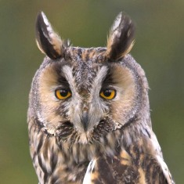
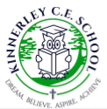

Autumn Term 2018

Welcome parents/carers of year 5 & year 6 pupils! This term, pupils in LEOs will aim to listen, work hard and begin to develop a confident approach to learning. As parents/carers, you play an important part in your child’s learning. Please support them by: reading to them and listening to them read; encouraging them to practise their weekly spellings and times tables; and supporting them with their homework tasks.
Many thanks,
Mrs Fogarty.

Below, is an overview of topics which will be explored during this term:

English:
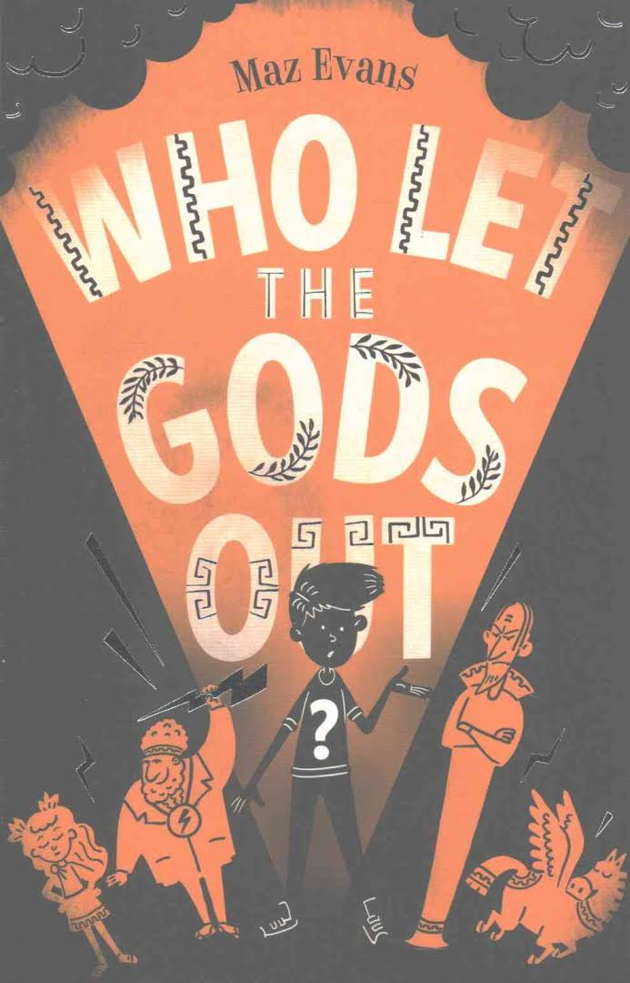
Using ‘Who let the Gods out’ by Maz Evans as our focus text, LEOs will first focus on narrative writing, which will enable them to explore aspects of grammar, and understand the impact of descriptive and figurative language. Deduction, inference, summarising and prediction skills will be practised. This novel links in with our History topic of Ancient Greece, and R.E.,where we consider ancient Gods, and the part God plays in our lives.
Later in the term, we will explore letter writing, radio reports, and journalistic writing. In addition, we will recap on the conventions of poetry and features of non-chronological reports. Play-scripts and performance skills will be revisited in the end of term production. Trips, where possible, visits and role-play opportunities will be woven into our literary journey this term.

During Guided Reading sessions, reading comprehension skills will be practised using a wide range of narrative and non-fiction texts. Spelling strategies will be taught implicitly and explicitly during Literacy sessions.

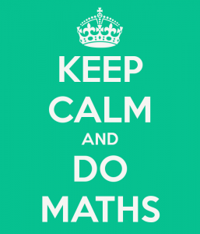
Mathematics:
To become a confident mathematician and attain mathematical fluency, LEOs need firstly, to have a rapid recall of all the times tables up to 12 x 12. This will enable them to concentrate on strategies, methods and concepts.

In the autumn term, we recap on previous learning, consolidate and develop pupils’ knowledge of number: place value, rounding, partitioning, calculating, decimals, and problem-solving. We focus on all four operations and methods, and develop mathematical language. We use equipment, video clips and games. Later we explore shape, and conversion between units of measure and mass.

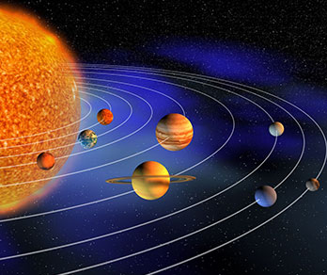
Science:
‘Earth, the Moon and our Solar System’ will be our first focus until half term. After that LEOs will be studying ‘Animals including humans (circulatory systems).’ Through practical experiments and modelled investigations, pupils will begin to deepen their scientific thinking and reasoning.

Music:
Pupils embark on a journey through the solar system, discovering how space inspired composers such as Claude Debussy, Gustav Holst and more recent composers such as David Bowie. LEOs will also try their hand at creating space-influenced pieces of music.

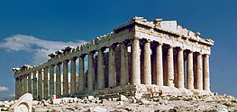
History:
Ancient Greece is our focus for this autumn term. LEOs will study Greek life, the achievements of famous Greeks, democracy and their influence on the Western world. We will briefly explore Greek Myths and the Gods they worshipped.

Design Technology/Art:
We will be investigating and building Shelters (this links with Ancient Greece). Later LEOs will be using the medium of clay to design and make Greek Urns.

Computing:
LEOs will study Internet Safety, also the basics of word processing, power-points, radio reports, and learn to make short animation videos.

R.E.
Pupils will have an opportunity to reflect and question with our first topic ‘What part does God play in our lives?’ Later, we will explore Judaism and the religious festivals which are important to Jewish people. LEOs will also study and celebrate important religious festivals in the Christian calendar.

French
‘Ma Ville’ will allow pupils to learn the vocabulary for their local area, and ‘le carnival des animaux’ will help them to learn animal names related vocabulary.

P.S.H.E.
At the start of term we consider our aims and aspirations in ‘New Beginnings’ (SEAL). After half term, we focus on the importance of ‘Keeping Healthy’.

P.E.
LEOs will practise Tag Rugby and football this term. (Sessions are usually Mondays and Thursdays. Pupils should always keep a P.E. kit in school.)

Homework
This is given out every week on a Thursday and should be handed in by the following Wednesday. Homework consolidates learning from earlier in the week or encourages pupils to expand their topic knowledge. It comprises either Maths or English, or Topic work. Pupils are also expected to practise their focus Times Table and their weekly spellings. (In class, I encourage LEOs to find strategies to remember their spellings; we discuss how to break words down or use images to aid recall.)

